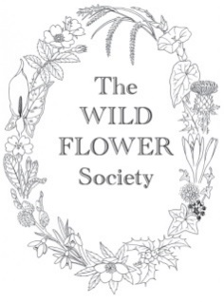
The Wild Flower Society Grant Application Form
Grants for Research Projects

The Wild Flower Society gives small grants, typically up to £250, towards botanical research projects based on the flora of the British Isles. We support projects that contribute to plant conservation, or that further botanical education or the promotion of field botany.
Please apply by sending this completed form to wfs.grants.fay@gmail.com for consideration by the Executive Committee which meets in early March and November each year. If you are applying for more than one grant, please fill in a separate form for each activity.
Please note that as a condition of our project grants, successful applicants are asked to write an article for our Members’ magazine. This should be aimed at an audience who are interested in wild plants but do not all have formal scientific training.

Name of contact
Email
Telephone
Supervisor name and email
Academic Institution

Title of Proposed Research
Please provide a short (<200 words) laypersons’ summary of your proposed subject.
The Committee are familiar with wild plants but do not necessarily have backgrounds in ecological theory or genetics.
Itemised costing.
Costs we have covered in the past include travel costs for UK botanical fieldwork, equipment for field and taxonomic studies (sample collection materials, magnification equipment etc.) and identification guides.
The aims of the Society are: to promote a greater knowledge of field botany among the general public and in particular among young people; to advance education in matters relating to the conservation of wild flowers and of the countryside; and to promote the conservation of the British flora.
Please explain how your project will help to further at least one of these aims.

Data collected on this form, and accompanying contact details provided by email, will be used by the officers and executive committee members of The Wild Flower Society for the assessment of applications, and for the administration of any grants awarded. The Wild Flower Society’s Privacy Notice can be viewed in full on our website, www.thewildflowersociety.org.uk

